
THREE PARKS INDEPENDENT DEMOCRATS
Cathedral Station ♦ P.O. Box 1316 ♦ New York, NY 10025 ♦ (212) 866-6378
Website: ThreeParksDems.org ♦ Email: ThreeParksDems@aol.com

President | Editor | District Leaders
Josh Pepper | Ray Schwartz | Bob Botfeld
 |  | Cynthia Doty
 |  | State Committee
 |  | Lynn Thomas
APRIL 11, 2007

FEATURED SPEAKERS: |  | Cong. CHARLES RANGEL,  Dick Dadey, Exec Dir,  Citizen’s Union
TOPIC: |  | Cleaning Up Government
DATE: |  | Wednesday, April 11, 2007
TIME: |  | 8:00PM
PLACE: |  | American Youth Hostel (HI-NY)  891 Amsterdam Avenue at 103rd Street
ROOM: |  | Chapel
AGENDA |  |  | CALENDAR
7:45PM Sign-in  8PM Call to Order |  |  | Wed., April 11, 8PM  Three Parks Meeting  PLACE: Hostel, 891 Amsterdam Ave. Chapel
1. President’s Report & |  |  | Wed. , April 25, at 8 PM  Three Parks Board Meeting  PLACE: Hostel, 891 Amsterdam Ave.
 | Announcements
2. District Leaders' Reports |  |  | Thurs., April 26 at 7:30 PM  Three Parks Progressive Party(ing)  PLACE: Carne, 105th and BWY
3. Congressman Charles Rangel
Dick Dadey, Executive Director,
 | Citizen’s Union |  | Sunday, April 29, 3-6 PM  Three Parks Fundraiser  PLACE: Meridiana, 2756 Broadway, 105th & 106th St.  Wed., May 9 at 8:00 PM  Three Parks Meeting at the Hostel
4. Judicial Delegate nominations
5. State Committee Reports
7. Adjournment

President’s Column

Josh Pepper

Greetings! I am still settling into my new post, and I encourage all of you to help me by continuing and even increasing your activities with the club. Our board meetings take place on the fourth Wednesday of each month, and club members who are not on the board are always welcome to come and observe. Also, anyone who has an issue that he or she wants the board to address is welcome to write or e-mail me in advance of the board meeting with his or her issue. Any issue that furthers the mission of the club is fair game for the board, subject to time considerations. My e-mail address is jpepper9@nyc.rr.com.
We have also been in the process in the past few months of forming additional committees to further the club’s mission. We now have a Membership Outreach committee to expand the reach of the club. Anyone interested in joining this committee should contact Dan Berger at dan@danjberger.com or Lynn Max at lbendermax@excite.com. We also are forming a Community Issues committee to discuss issues currently of interest to club members and report to the club and make recommendations regarding potential club action on the issue. Anyone interested in serving on this committee should send me an e-mail at the address above.
I hope you all came to our last meeting. We had the privilege of hearing Democratic State Party co-chair Dave Pollak enlighten us about his plans for the party in the upcoming year. Carrie Marlin, from the staff of our Assemblymember Danny O’Donnell, also spoke to us about items in the state budget.
Our next meeting will take place on Wednesday, April 11, at the Hostel (HI-NY at 891 Amsterdam Ave. Note that we will be back in the chapel as usual. Dick Dadey, executive director of Citizen’s Union, will be speaking to us about lobbying reform efforts in Albany.
We had another progressive party at Carne on Thursday, March 29th, and we will have the next one on Thursday, April 26th. I hope many of you will come to that. And don’t forget our annual gala at Meridiana, on Sunday, April 29th. See you then!

THREE PARKS Progressive
Democratic Party(ing)!
By Theresa Canter

Thursday, April 26th will be the next Three Parks Progressive Democratic Party(ing) event at CARNE, 105th and Broadway. Come on out and join us, it’s a lot of fun! Not only have we shared good conversation (with a focus on the 2008 Presidential election!), we’ve also gained two new club members!

The last Thursday of each month is the day you are all invited to come together to share ideas and talk politics in an informal setting. Our regular club meetings are structured and don't always allow for conversational debate. This is an opportunity to introduce your friends and neighbors who enjoy politics to the political community of Three Parks. Of course, people will be responsible for the cost of their own drinks and food.

WHERE: CARNE, 105th and Broadway
WHEN: Thursday, April 26th, and May 31st.
TIME: 7:30 PM to.....?

District Leader Report

By Bob Botfeld

SPECIAL ELECTIONS: Who determines the winner? It could be you.

Nearly every year editorial writers, good government groups, and others complain about the small, select group of people who have an inordinate amount of influence in determining the outcome of New York State special elections for assembly members and senators.

In New York State, special elections are called whenever a legislator is replaced in the middle of a term. It happens fairly often. According to the study by the Citizen’s Union Foundation, 31% of our legislators were first elected through special elections. On the West Side, both Linda Rosenthal and Scott Stringer were first elected to the Assembly through special elections. This spring there are two special legislative elections on Staten Island.

Who are these people who have this inordinate amount of power? It could and should be you. They are called County Committee members.

Bi-annually, Three Parks Independent Democrats, assembles a slate of candidates from our club members to run for County Committee for the election districts in our area. Three Parks has over 80 slots to fill this year.

The County Committee has this power because whenever there is a midterm vacancy in the state legislature (or US House of Representatives), the County Committee members in the legislative district meet to elect the Democratic nominee - on the Upper West Side this, of course, means the eventual winner. (Except for one other meeting, it is probably the only meeting a County Committee members needs to attend.).

As a County Committee member, your vote can be very important. In a recent County Committee election, the winning Democratic nominee was selected by a margin of a single vote.

If you would like to be a County Committee member, call Bob Botfeld at 212-865-1450 or Cynthia Doty at 212-749-4085.

ZONING UPDATE

We are waiting for the Department of City Planning (DCP) to release the certified plan for the 96th to 110th Street West Side rezoning. You can see the proposed plan at the DCP web site at http://www.nyc.gov/html/upper_west_side/index.shtml.

Unofficially, the DCP has promised that the plan will be released by the end of April. Then the ULURP process can begin. The first step after that are hearings by Community Board 7.

The importance of the rezoning cannot be underestimated. This past month, the Jewish Home and Hospital (JHH) on 106th presented their plan for expansion at an informational meeting of the Land Use Committee of CB7. The JHH would like to modernize their facilities on 106th and 105th Streets and to sell part of that land to a developer for high rise luxury condominiums. In their presentation, they acknowledged the impending rezoning, and stated that they would not challenge or seek to delay the rezoning. Without the rezoning, they too would be building 35+ story buildings to finance their activities. At the community board meeting, neighborhood residents including Three Parks members Bob Botfeld, Lynn Max, and Cynthia Doty spoke against the building of more towers in the neighborhood.

Boycott the Saigon Grill

By Cynthia Doty

Join the fight to support the delivery workers at Saigon Grill at 90th St and Amsterdam Ave. Workers were locked out of the restaurant after they announced plans to unionize and file a lawsuit against the owners. They are protesting their poor working conditions, including earning below minimum wage (often less than $2/hour) and having no holidays. Assembly Member Linda Rosenthal is helping organize the protests along with Justice Will Be Served. Contact her office or CFD to help with leafleting.

Reform Day 2007:
Spring Cleaning in Albany
On Monday, April 23, reformers are taking the fight for comprehensive change to the State Capitol.
Reform Day is co-sponsored by 17 diverse civic organizations. The event will bring together hundreds of New Yorkers from all over the state to deliver a clear message to lawmakers in Albany: this year, it's time to finish the job of reforming state government. The day includes a rally outside the capital, lunch with elected officials, and a series of "People's Hearings" on issues including Redistricting, Campaign Finance, Voting Machines and the need for Transparency in Government. FREE buses are leaving from New York City. Seating is available on a first-come, first-serve basis. For more information go to www.commoncause.org/reformny2007.

Three Parks ANNUAL FUNDRAISER ON APRIL 29TH

It’s that time of year again! On Sunday, April 29th, 2007, Three Parks Independent Democrats will celebrate 32 years of Democratic activism on the Upper West Side with its annual benefit from 3:00 p.m. to 6:00 p.m. at Meridiana, 2756 Broadway between 105th & 106th Streets.

This year, we will present the Ted Weiss Public Service Award, named in honor of the late West Side Congressman, to Congressman Charles B. Rangel in recognition of his appointment as Chairman of the House Ways and Means Committee, his three decades of service in the House of Representatives and his fierce commitment to peace and justice highlighted most recently by his unwavering stance against the Iraq war.

Landmark West! will be awarded the Jesse Crawford Community Service Award for their distinguished work to preserve the best of the Upper West Side's architectural heritage. We will also be bestowing the Three Parks Green Award on Lisa Rainwater, Riverkeeper’s Indian Point Campaign Director, for her efforts to safeguard the ecological integrity of the Hudson River and close the Indian Point nuclear power plant.

Mark your calendars and then come enjoy the celebrations!

Three Parkers Protest
the Iraq War

By Cynthia Doty

Over 30 people marched with our Three Parks banner on Sunday March 18th, joining tens of thousands from all over the city marching from midtown to the UN to protest the Iraq war. Then on Monday night, March 19th, over 150 people came out to our candlelight vigil in Straus Park. We joined with MoveOn to organize this solemn marking of the anniversary of the war. We read the names of NY soldiers who had died, held moments of silence for all the dead, wounded, and other victims of the war including the Iraqi civilians, and sang songs to protest our continuing involvement and to appeal for peace. It was a truly moving gathering of our community! I was proud to be a neighbor and a Three Parker!

Salvation Army-- DOING THE MOST GOOD? —

I DON’T THINK SO!

By Ralph Andrew

Representatives from at least four West Side Democratic Clubs--including Chelsea Reform, CFD, Three Parks and Broadway Dems--as well as Assembly Member Richard Gottfried and others engaged in an informational picket last week at the Army’s spring Gala at the NY Hilton where the nation’s second wealthiest charity raised hundred of thousands of dollars. In January of this year, the Salvation Army began evicting all of the women living in its residences for moderate income and needy tenants. Another 600 units of affordable housing will be lost if they are successful in court with their evictions against all the tenants in their Manhattan women's Residences.

Marc Landis, DL 67th AD, is leading the pro bono legal team from Phillips Nizer along with the Met Council on Housing and the Manhattan Legal Services in representing the tenant associations and the brave tenants who are willing to fight to preserve their homes. The Salvation Army's eviction efforts rely on a narrow exception to New York's rent-stabilization regulations for "buildings that are operated exclusively for charitable purposes on a non-profit basis" -- a standard which it is argued should no longer apply to these properties since the Salvation Army is conducting mass evictions for the purpose of maximizing the sale value of the residences.

State Senator Liz Krueger, City Council members Rosie Mendez and Dan Garodnick, Assembly Members Dick Gottfried and Brian Kavanagh, and Manhattan Borough President Scott Stringer are all on the front lines of this effort to protect the tenants' homes.

To date, the efforts in State Supreme Court have led to the issuance of a temporary restraining order which prohibits the Salvation Army from taking any steps at this time to evict the tenants. The next hearing is scheduled for April 20.

Ironically, this protest had some comical moments as some of us, dressed in red as Santa-like figures with brass bells, red kettles and all—provided a wonderful photo-op for Channel 4 and numerous other news outlets. Only problem was that at least one clown put a dime in my kettle instead of taking and reading the informational flyer!

VOTE 2008: Symposium on
Election Reform and NY Voting
Machines

Speakers: Hon Rush Holt; Douglas Kellner; Ion Sancho; Esmeralda Simmons, Esq.
April 12, 2007, 8AM -10AM
55 Fifth Ave @12th ST
Register@ nyevents@pfaw.org

ANNUAL RIVERSIDE POETRY EVENT
SUNDAY - APRIL 29th - 1:30 PM
Held on Riverside Drive
On the Island at 103rd Street
RAIN LOCATION INDOORS AT
310 Riverside Drive
COME - READ - LISTEN - ENJOY

THE BULLY PULPIT
(How Sweet It Is!)

By Estelle Levy

‘Bully Pulpit’ powers are inherent to the positions held by all our elected representatives—City, State and National. The willingness to use this power on behalf of constituents depends on the elected individual, on the district, on the issue, on the elected official’s sense of what is and what is not political ‘risk-taking’ and it depends on how one defines Public Service.

We in THREE PARKS INDEPENDENT DEMOCRATIC CLUB have a gem among
us--representing us. It is our own Danny O’Donnell, our own State Assemblyperson! This story is about a Mitchell Lama Coop in OUR DISTRICT; a Board that once repaired an internal leak and several years later chose not to when it reappeared. Our Danny O’Donnell knows Mitchell Lamas of every stripe have received State benefits galore for decades. After a year or so of repair requests, denials, fault assignment, not my responsibility claims, I wrote to Danny’s 104th Street Constituent Office. Well, a letter to the Coop was sent—signed by our own Danny himself. After a very brief bit of ‘attitude’, a transformation took place: courtesy, cooperation, rescraping, replastering, repainting all were done in a flash—ONLY BECAUSE OUR OWN DANNY O’DONNELL WAS WILLING TO HAVE A LETTER SENT SIGNED BY HIM.

Our Danny O’Donnell’s sense of being the
People’s Representative has been clear over time. By this sharing it is again confirmed. No doubt he uses his vested, discretionary and Bully Pulpit powers on behalf of many. I for one wish to thank him for being a public service Role Model we all value, respect, vote for and are proud to call him “OUR OWN DANNY O’DONNELL.”

Can judicial incompetence and judicial corruption be solved by appointing rather than electing judges?
By Alan Flacks
An all-appointive system for judges is no better, and probably worse, than an elective system as history has demonstrated that neither method guarantees a smarter and "more nearly honest" judiciary.
The fact is that here in Manhattan the election of judges has worked very well in both Civil and Supreme and Surrogate courts. With few exceptions, the Reform Democratic movement's independent, merit screening panels have improved the judiciary with every judge elected to the bench. In contrast, the mayoral appointments to Family and Criminal courts have been of mixed quality. And even on the Federal level, the usually excellent appointive system has seen conservative extremists on the bench. Nor is corruption absent. (Here, Second Circuit Court of Appeals appointed Judge Martin Manton left the bench in the late 1930's for taking bribes in patent cases.)
There is another danger inherent in judicial appointments: the danger of concentrating the power to select judges--our independent third branch of government--in too few hands. While we have seen good judges who were appointed, overall the best method is election, where the ultimate power resides in the people.
The best judges have more than just a thorough knowledge of the law. They need "judicial temperament"--to be courteous to litigants and the others in their courtroom, to exercise self-control, to be even-handed and patient, and to maintain control of their courtroom.
In appointment, as in election, the best guarantee of honest, fair, and independent judges is an informed and involved electorate. When voters, like us, care about the quality of the judges who enforce our laws and decide our disputes, we get better judges.

It is with sadness that we note the passing of Lucille Maillard, a past president and long-time board member of Community Free Democrats. Lucille was always a strong advocate for our community. She will be dearly missed by all her many friends, neighbors and fellow activists.

Congressman Rangel
Book Signing

Join us as DL21C's Political Book Author Series continues with Congressman Charles Rangel (D-NY), Chair, House Ways and Means Committee and author of "And I Haven't Had a Bad Day Since: From the Streets of Harlem to the Halls of Congress".

Tuesday, April 10
7:00 pm at Bar Nine 807 9th Ave.
(b/w 53rd & 54th Streets)
RSVP at http://www.dl21c.org

Buy a copy of the book: it’s a wonderful read, full of humor, history, and political anecdotes!

HOUSING JUSTICE VIGIL

The Interfaith Assembly on Homelessness and Housing will hold it’s 23rd annual Interfaith Convocation and Overnight City Hall Vigil for Housing Justice on:

Thursday, May 3, 2007
6:30 PM
St. Paul’s Chapel
Broadway and Fulton Street
Manhattan

For more information on the Convocation call 212-316-3171 or visit their website at iahh.org.

NEWSLETTER ARTICLES

Submissions to the Three Parks Newsletter should be made two weeks prior to the the next Three Parks meeting. Please email the submissions as a word document to: tappsch@nyc.rr.com
Every submission will be considered subject to space constraints.

Partial Testimony Given at the Landmarks Preservation
Commission
Re: Creating a Historic District for Manhattan Avenue,
104th St. - 106th St.

By Cynthia Doty

For the last two years we have been working very hard to protect and preserve the wonderful character and diversity of the neighborhood from W. 97th Street to W. 110th Street from Riverside Drive to Central Park. Through the major mobilization of the community and the leadership of all our local elected officials we have developed a new zoning plan that we believe protects the rich architectural heritage of the area, preserves the diversity of housing stock, and sustains the cherished neighborhood character and sense of community while still allowing for responsible new development. Landmarking this section of Manhattan Ave is a crucial part of this preservation movement.

I believe that New York’s first greatest asset is its people and the second is its neighborhoods. New York is its neighborhoods! This section of Manhattan Ave has a long history of being a neighborhood. These 40-some buildings are true architectural treasures that have allowed this neighborhood to thrive. They are not only links to our past but help sustain an important sense of community.

I urge you to approve this application and help preserve not only a series of wonderful historic buildings but also the lynchpin to a wonderful community and neighborhood that is currently threatened by real estate developers’ hunger to tear down any small structures they can find and build massive new buildings. These townhouses are very vulnerable in face of this current speculative trend that is steamrolling throughout the Upper Westside. Your vote to landmark this area will definitely help to preserve this neighborhood.

THREE PARKS INDEPENDENT DEMOCRATS
Cathedral Station P.O. Box 1316 • New York, NY 10025 (212) 866-6378

Please pay your 2007 dues by filling out the form below and bringing it to the next meeting or by mailing it with your check to:

Three Parks Independent Democrats
Cathedral Station P.O. Box 1316
New York, N.Y. 10025
Attn: Treasurer
-----------------------------------------------------------------
2007 MEMBERSHIP FORM

New Member___

Renewal___

Membership Category -- Check One

Individual ($20) ____

Family -- two adults in the same household ($30) ____
Student/Senior Citizen/Low Income ($8)____
Sponsor ($40)____ Patron ($100) ____

Name_______________________ Date___________________
Address________________________________ Apt. #_______
City_________________________ State_____ Zip__________
Phone (H)___________________ (W)____________________
Email______________________________________________
Check here if you prefer to receive the newsletter via email.
Please make out all checks to “Three Parks Independent Democrats - Dues 2007"

Three Parks Independent Democrats
Cathedral Station P.O. Box 1316
New York, NY 10025

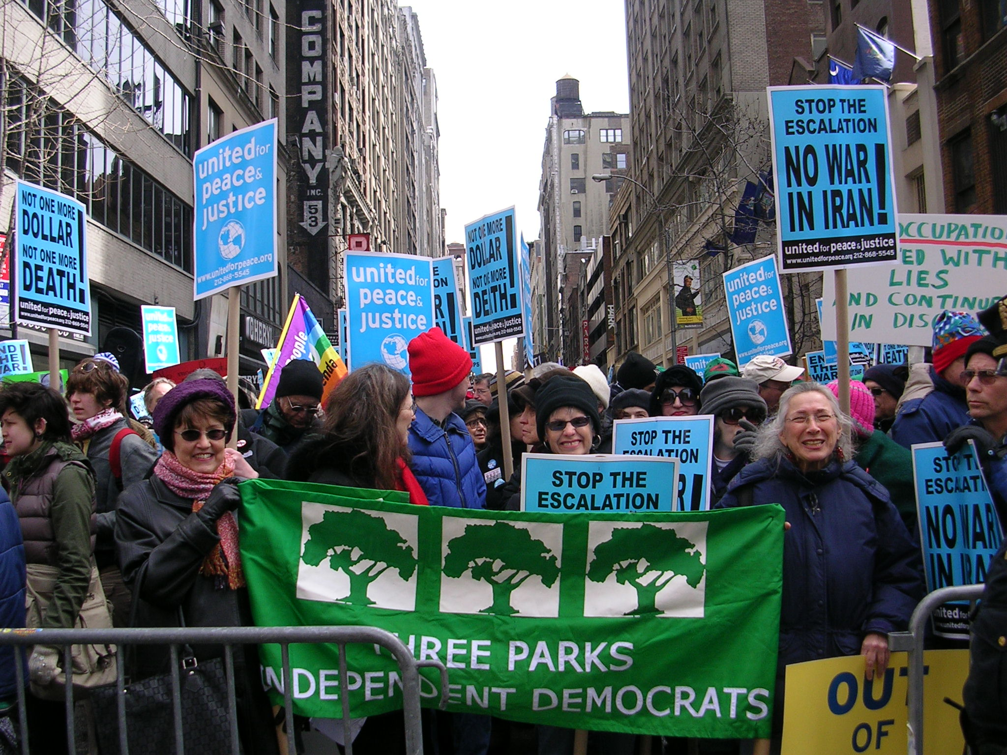
Three Parks at the March 18, 2007 Iraq War Protest March

