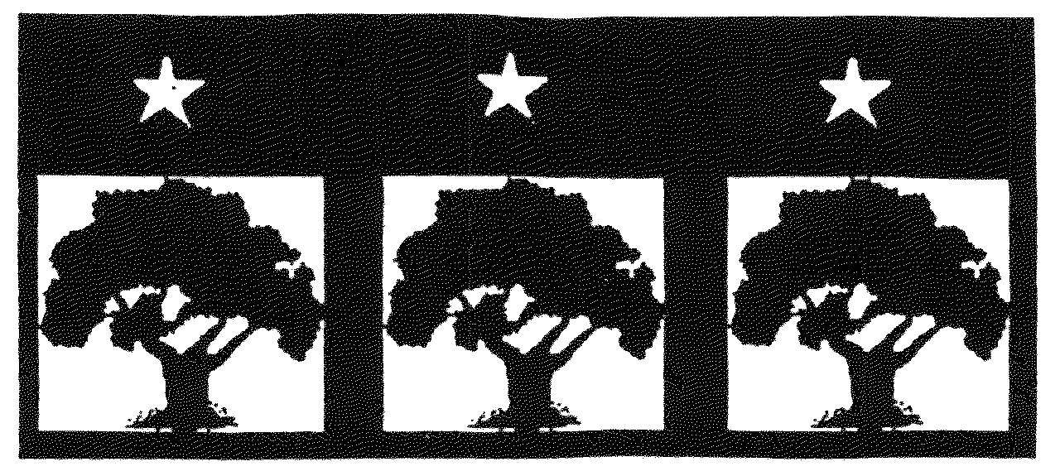
THREE PARKS INDEPENDENT DEMOCRATS
Cathedral Station ♦ P.O. Box 1316 ♦ New York, NY 10025 ♦ (212) 866-6378
Website: ThreeParksDems.org ♦ Email: ThreeParksDems@aol.com

MARCH 14, 2007
President | Editor | District Leaders
Josh Pepper | Ray Schwartz | Bob Botfeld
 |  | Cynthia Doty
 |  | State Committee
 |  | Lynn Thomas

FEATURED SPEAKER: | Dave Pollak, co-chair, New York State Democratic Committee  Assemblymember Daniel O’Donnell (invited)
DATE: | Wednesday, March 14, 2007
TIME: | 8:00 PM
PLACE: | Hostelling International New York (HI-NY)  891 Amsterdam Avenue at 103rd Street
ROOM: | Down Under

AGENDA

7:45PM Sign-in

8PM Call to Order

- President’s Report & Announcements
- District Leaders' Reports
- FEATURED SPEAKERS: DAVE POLLAK, Co-chair, New York State Democratic Committee Daniel O’Donnell, Assemblymember (invited)
- State Committee Reports
- New Business
- Adjournment
CALENDAR

Wed., March 14, 8PM Three Parks Meeting
PLACE: HINY 891 Amsterdam Ave at 103rd St., Down Under
Sunday, March 18, NYC Peace March
Meet at 12:30PM Broadway & 96th St.
Wed., March 28 at 8 PM Three Parks Board Meeting
PLACE: HINY 891 Amsterdam Ave. at 103rd St., Board Room
Thurs., March 29 at 7:30 PM Three Parks Progressive Party(ing)
PLACE: Carne, 105th and BWY
Wed., April 11 at 8 PM Three Parks Meeting
PLACE: HINY, 891 Amsterdam Ave. at 103rd St.
Wed., April 25 at 8PM Three Parks Board Meeting
PLACE: HINY, 891 Amsterdam Ave. at 103rd St.
Sunday, April 29, 3-6 PM Three Parks Fundraiser
PLACE: Meridiana, 2756 Broadway, 105th & 106th St.
President’s Column
Josh Pepper

First, let me say thank you to all of you who voted for me, and a special thank you to our President Emeritus, Theresa Canter, for her three years of devoted service to the club as president. I hope that I can do just as effective a job as she has done.
At our last meeting, the annual election of the officers and board members took place and we listened to an excellent presentation from club member Steve Max about challenges facing the new Congress and creating a progressive agenda for the future. We were also particularly privileged to have former Assemblymember Ed Sullivan speak to us about recent events in the Assembly. Special thanks to Ed for filling in at the last minute, when the blizzard prevented Danny O’Donnell from attending the meeting. Danny is planning to come to the next meeting if he can get back from Albany in time.
Speaking of which, the next Three Parks meeting will be Wednesday, March 14. Our special guest speaker will be Dave Pollak, co-chair of the New York State Democratic Committee. Dave has a lot to tell us about the present and the future of the State Party, so be sure to mark your calendar for this meeting, and invite your friends and neighbors.
Also, please mark your calendars for March 18th, when several groups are marching for peace. Having been against the war in Iraq from the very beginning, we expect to have a huge turnout under the Three Parks banner. Assemble at the northwest corner of 96th Street and Broadway. The march begins at 1 pm. We will march as a block under the Three Parks banner.
See you all on the 14th.
Three Parks wishes a speedy recovery to Joyce Miller

Medicare for All Campaign
By Cynthia Doty
One of the main demands voters are calling for all across the nation is reform in our system of health care coverage. We need Congress to hold hearings and enact major health care legislation…Now! One such legislation is HR 676, single payer healthcare for all or as some call it, Medicare For All. Health Care Now!, a nation-wide campaign for health insurance reform, is recommending April 4th as Martin Luther King National Healthcare Day.
We should focus our time, energy, money, and our organizations on the effort to save and expand Medicare for all and to enhance it and improve it so that it covers all of us for all of our healthcare needs. Medicare can and will be secure for all of us and will provide healthcare for all children and their parents and their grandparents as long as we need it under H.R. 676, single payer healthcare for all. This is the debate we must engage in -- healthcare as a human right, an entitlement for all under Medicare.
We cannot afford to mess around with little amendments to this and that bill. We need to demand, as the voters have overwhelmingly, that Congress hold hearings NOW.

Free Tax Assistance Days

Thanks to Congressman Rangel there will be free tax assistance for residents of our district. Please spread the word to your friends, neighbors and co-workers.

To file both your state and federal taxes for free at www.taxfreedom.com, you need to meet one of the following requirements:

- Earned $28,500 Adjusted Gross Income (AGI) or less in 2006; OR
- Qualify for the Earned Income Credit (EIC); OR
- Served Active Military Duty - includes Reservists and National Guard - with a 2006 Form W-2 from the military and earned an AGI of $52,000 or less.

Also spread the word about the Earned Income Credit and help ensure that all who are eligible receive this benefit.

For help, Free Tax Assistance Events will be held on March 10th at the Harlem YMCA, 181 W 135th St (11-4PM); March 17th at 216 Fort Washington Ave (12-5PM); and March 24th at 14-32 W. 118th St (12-5PM).

Creation of the Manhattan Valley Historic District

By Cynthia Doty

On Tuesday, March 13 the Landmarks Preservation Commission will hold a public hearing to consider designating the Manhattan Avenue Historic District, the section of 40 Queen Anne-style rowhouses on Manhattan Avenue, 106th St.,105th St., and 104th St. These buildings were built in the 1880's and 90's after the Cancer Hospital (also known as the Towers Nursing Home) opened at 106th St. and Central Park West. They were designed by C.P.H. Gilbert, J. Dunn, and E. Angell and marked the first major housing in the area from Central Park to Broadway that was all mostly open land. The Hospital is already landmarked and has been restored and converted into luxury condos. The hearing will take place in the Municipal Building, 9th Floor, 1 Centre St. Please attend or submit letters to show your support for preserving and protecting this historic section of our neighborhood.

NYC March to End the War
Sunday, March 18

United for Peace and Justice is organizing a march to the United Nations to protest the invasion of Iraq and to end the war and bring the troops home.

Three Parks members and friends are invited to attend the March as group. We will meet at:
12:30 PM Broadway and 96th St. (Northwest Corner). We will then travel as a group to the assembly points on 6th Ave. between 35th -39th Streets. For additional information, call United for Peace and Justice, 212-868-5545 or
www.unitedforpeace.org/nyc .

Zoning Update

By Cynthia Doty

The rezoning of the area from 97th St. to 110th St. is finally moving forward. As most of you know, this plan creates separate zoning districts for side streets and avenues, thereby limiting building heights and the transfer of air
rights. It includes the option to build higher on Broadway (to 9A or about 14 stories) if the developer provides lower-cost, so-called inclusionary, housing either on-site or within one-half mile of the site.
Over the past few months a number of issues have had to be worked out with the City Planning Commission (CPC). Through the leadership of Borough President Stringer and all our local officials, we believe an agreement has finally been reached. Now the Dept. of City Planning is preparing the formal application for the certification. We expect this to be presented to CB7 in April which would start the ULURP (Uniform Land Use Review Procedure), culminating in a vote by the City Council and approval by the Mayor. Along the way, there will be opportunities to testify at several public hearings.
Changes to the plan may be made at some stages in this process, so stay tuned and be ready to come express your views.

Discussion on Rent Regulation

A panel discussion on the future of the New York Rent Regulation System will be held at the:
Fordham Law School, McNally Hall
(Corner of 62nd St. and Columbus Ave.)
March 26th, 2007
6:30 PM
For additional information call the Donald & Paula Smith Family Foundation at 646-452-9995.

More Funding Needed for
Homelessness Prevention
By Cynthia Doty
This year many improvements were made to the NYC budget, thanks to the City Council’s early negotiations with the Mayor. Libraries, for example, were given budget lines. However, the Mayor did not include several essential programs needed to stem the rising numbers of homeless and hungry in our city. Some of these are: The City-Task Force on Housing Court ($550,000); Legal Services to Prevent Evictions ($2.5 million); Citywide Homeless Prevention Fund ($500,000); Legal Assistance to Enroll Youth and Adults with Disabilities in SSI ($2.5 million); Emergency Food Programs ( $1.5 million). Instead these will have to be added in and advocated for by Council Members. Please let your representatives know how important these services are to preventing homelessness and hunger in NYC.

ANNUAL FUNDRAISER ON
APRIL 29TH

It’s that time of year again! On Sunday, April 29th, 2007, Three Parks Independent Democrats will celebrate 32 years of Democratic activism on the Upper West Side with its annual benefit from 3:00 p.m. to 6:00 p.m. at Meridiana, 2756 Broadway between 105th & 106th Streets.

This year, we will present the Ted Weiss Public Service Award, named in honor of the late West Side Congressman, to Congressman Charles B. Rangel in recognition of his appointment as Chairman of the House Ways and Means Committee, his three decades of service in the House of Representatives and his fierce commitment to peace and justice highlighted most recently by his unwavering stance against the Iraq war. Landmark West! will be awarded the Jesse Crawford Community Service Award for their distinguished work to preserve the best of the Upper West Side's architectural heritage. We will also be bestowing the Three Parks Green Award on Lisa Rainwater, Riverkeeper’s Indian Point Campaign Director, for her efforts to safeguard the ecological integrity of the Hudson River and close the Indian Point nuclear power plant.

Mark your calendars and then come enjoy the celebrations!

Judicial Conventions
will be Held in 2007

The United States Supreme Court has decided to review the decision declaring as unconstitutional the NY statute governing judicial nomination conventions.
On Thursday, March 1, 2007, the trial Judge, Judge Gleason, signed a stay of enforcement of his own decision through the 2007 election cycle. As a result, there WILL be judicial nominating conventions this year.

Election Results
February 14, 2007 Club Meeting

Club Officers
President: Josh Pepper (32)
First Vice President: Theresa Canter (31)
Second Vice President: Judy Wood (30)
Treasurer: Ellen Flax (31)
Corresponding Secretary: Ray Schwartz (31)
Membership Secretary: Lynn Bender Max (31)
Recording Secretary: Jock Davenport (32)

Club Board of Directors
Dan Berger (32)
Corine Pettey (31)
Ernestine Gallagher (29)
Milivoy Samurovich 30)
Arlene Geiger (29)
Ken Tulloch (28)
Daniele Gerard (29)
Yvonne Vulliemoz (28)
David Kogelman (29)
David Weiman (29)
Marie Lunn (29)
Lauren Williams (27)
Maryann Marks (28)
Patrick O’Shaughnessey (27)
Three Parks sends our condolences to Clubmember David Lazarus on the passing of his father and to Clubmember Christine Fenno on the passing of her mother.

THREE PARKS INDEPENDENT DEMOCRATS
Cathedral Station P.O. Box 1316 • New York, NY 10025 (212) 866-6378

Please pay your 2007 dues by filling out the form below and bringing it to the next meeting or by mailing it with your check to:

Three Parks Independent Democrats
Cathedral Station P.O. Box 1316
New York, N.Y. 10025
Attn: Treasurer

2007 MEMBERSHIP FORM

New Member___

Renewal___

Membership Category -- Check One

Individual ($20) ____

Family -- two adults in the same household ($30) ____
Student/Senior Citizen/Low Income ($8)____
Sponsor ($30)____ Patron ($100) ____

Name_______________________ Date___________________
Address________________________________ Apt. #_______
City_________________________ State_____ Zip__________
Phone (H)___________________ (W)____________________
Email______________________________________________
Check here if you prefer to receive the newsletter via email.
Please make out all checks to “Three Parks Independent Democrats - Dues 2007"
Three Parks Independent Democrats
Cathedral Station P.O. Box 1316
New York, NY 10025

